**Launching An EC2 Instance**

1. Log in to the AWS console and click on EC2 from the services tab

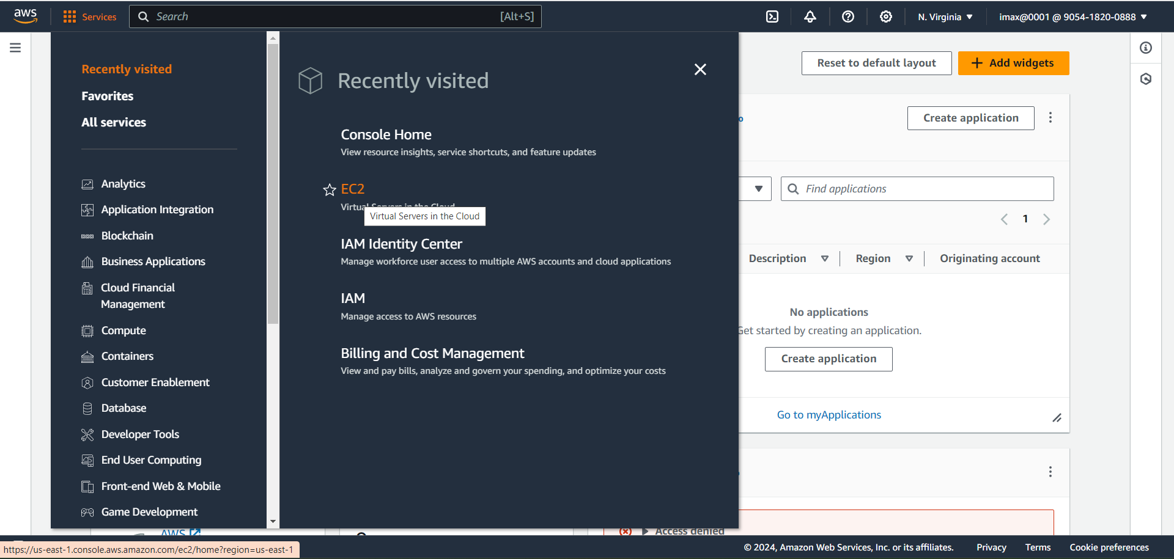

1. Click on launch instance from the EC2 dashboard

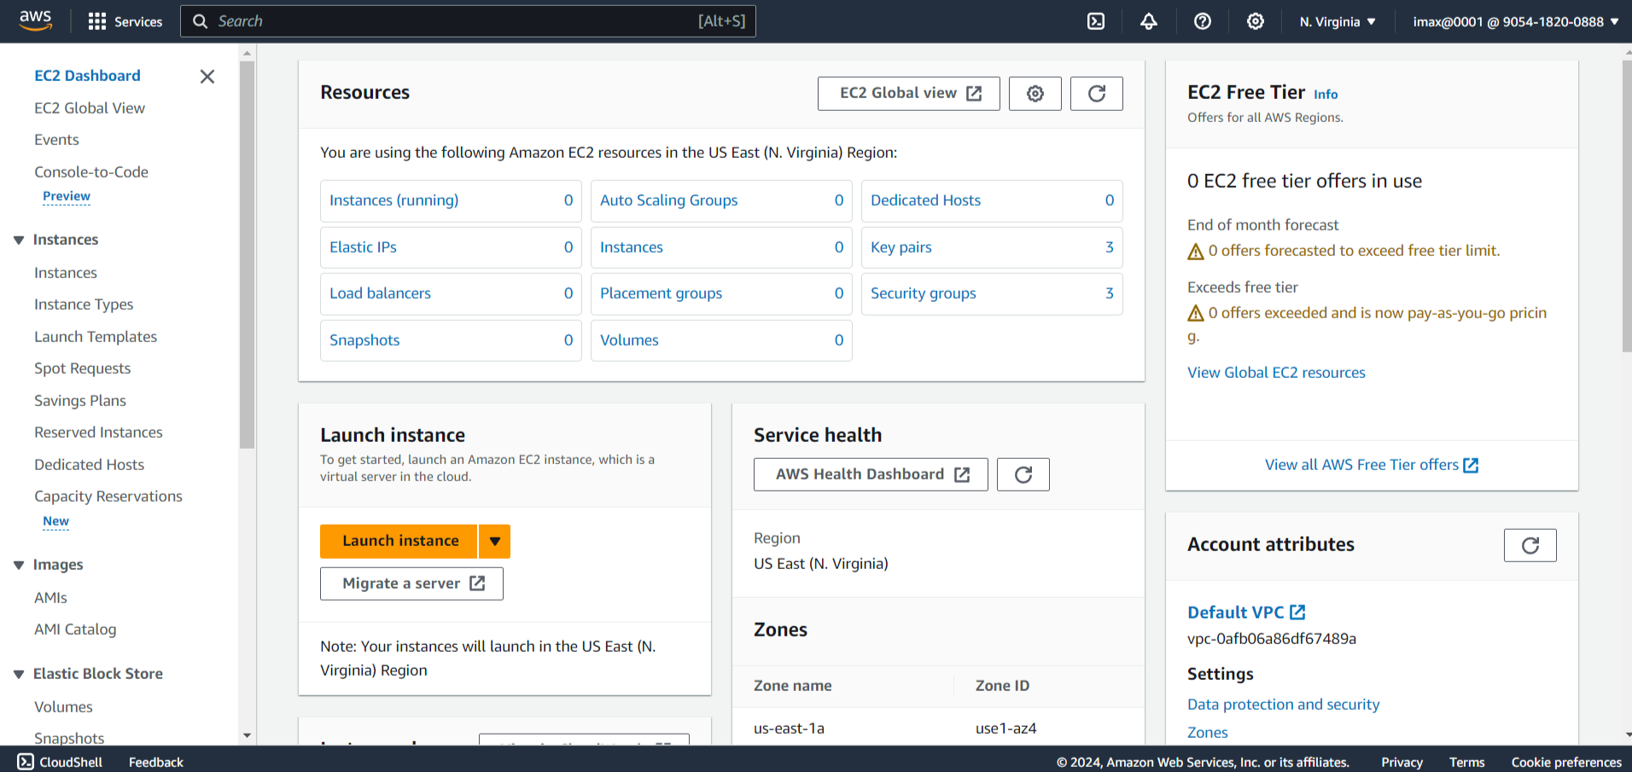

1. Enter Name in ‘Name and tag’ field

(A tag is a label that you assign to an AWS resource. Each tag consists of a key and an optional value, both of which you define.

* Key: Up to 128 Unicode characters in UTF-8
* Value: Optional tag value up to 256 characters in UTF-8)

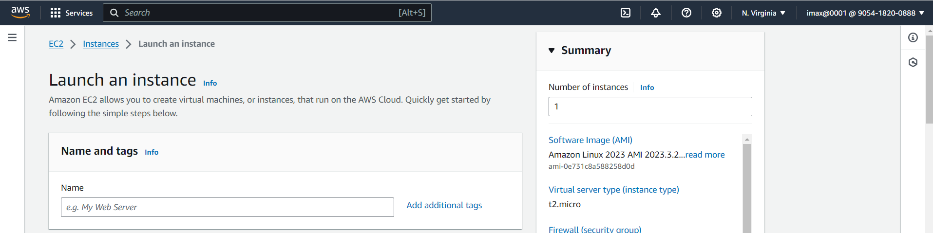

1. Amazon Machine Image dictates which operating system will be getting. For ex- ubuntu.

Click on ‘Browse more AMIs’

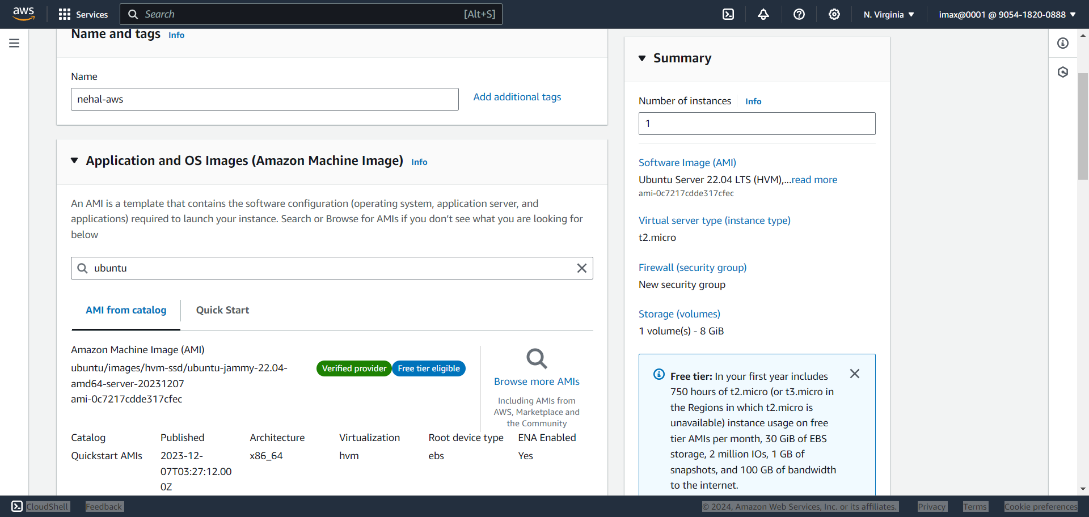

1. Choose an Amazon Machine Image (AMI)

* AWS Marketplace AMIs: Marketplace is a platform where vendor create their own AMIs and put up for paid use
* Community AMIs: it is a platform where AWS users create their AMIs and share it with the community for free use
* My AMIs: If we want to avoid doing redundant work, we can create an AMI and use it to launch new instances. This saves a lot of time.

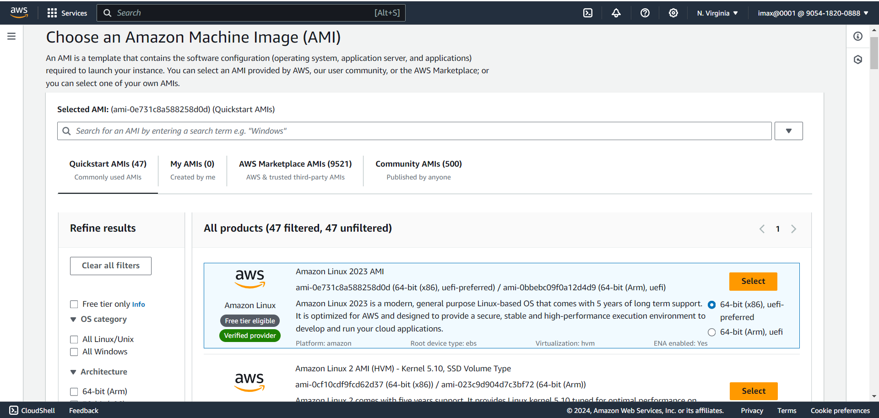

* We will go with the default QuickStart AMIs option and select Ubuntu Server 22.04 LTS (HVM), SSD Volume Type

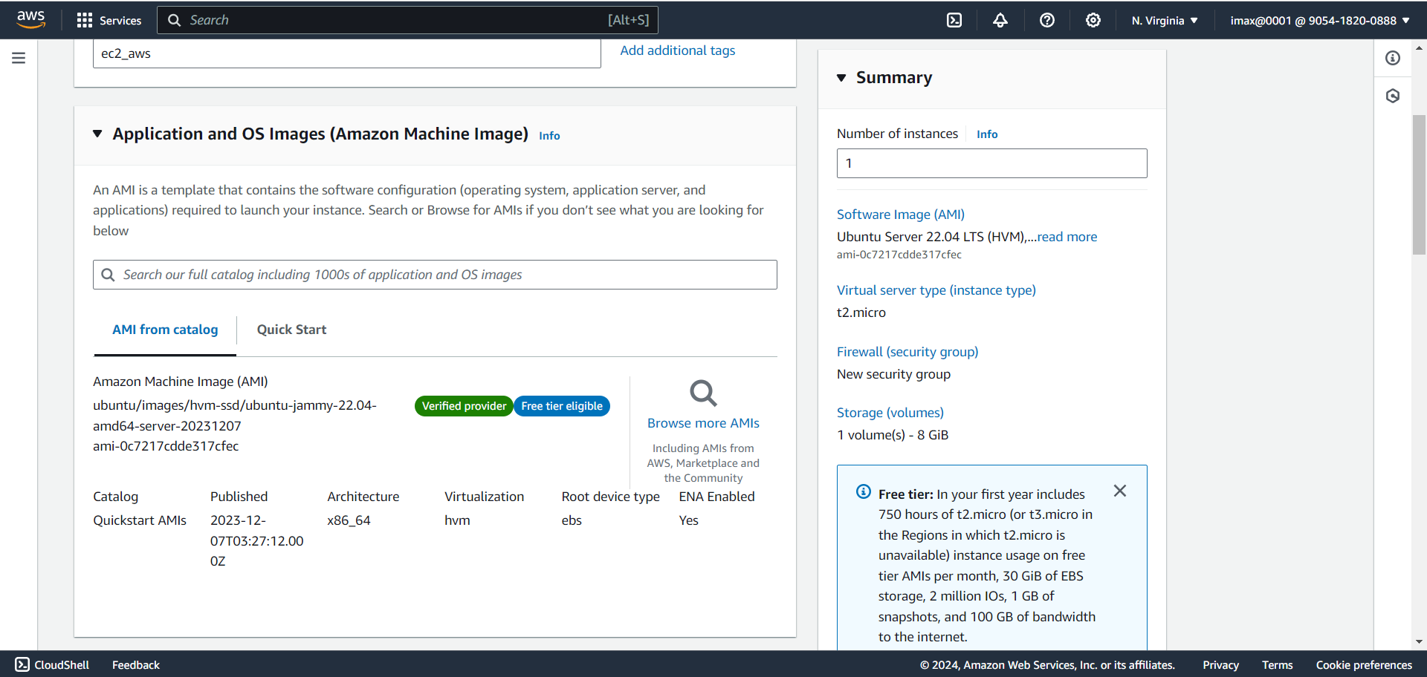

1. Choose an Instance Type: Instance type decides the CPU, memory and network capacity of the instance (for now we will select t2.micro, which is a free tier eligible instance type)

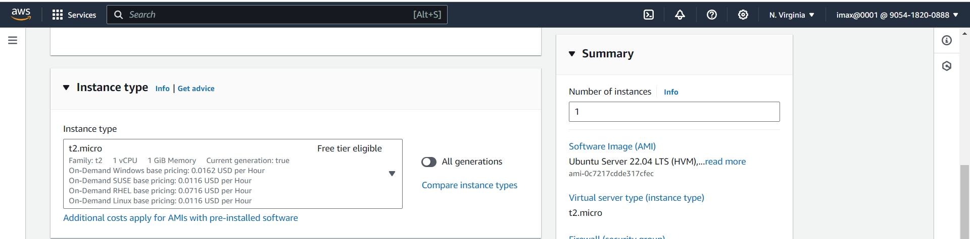

1. Key pair

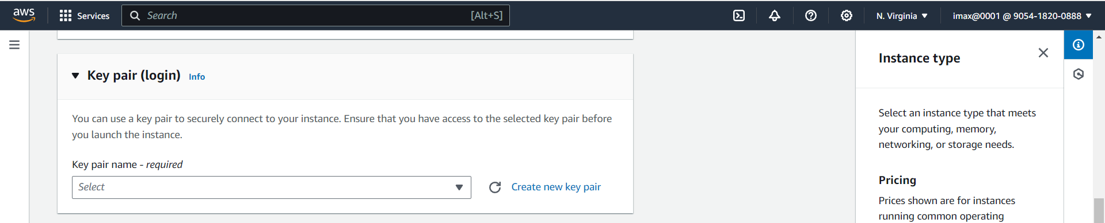

* Click on ‘Create new key pair’

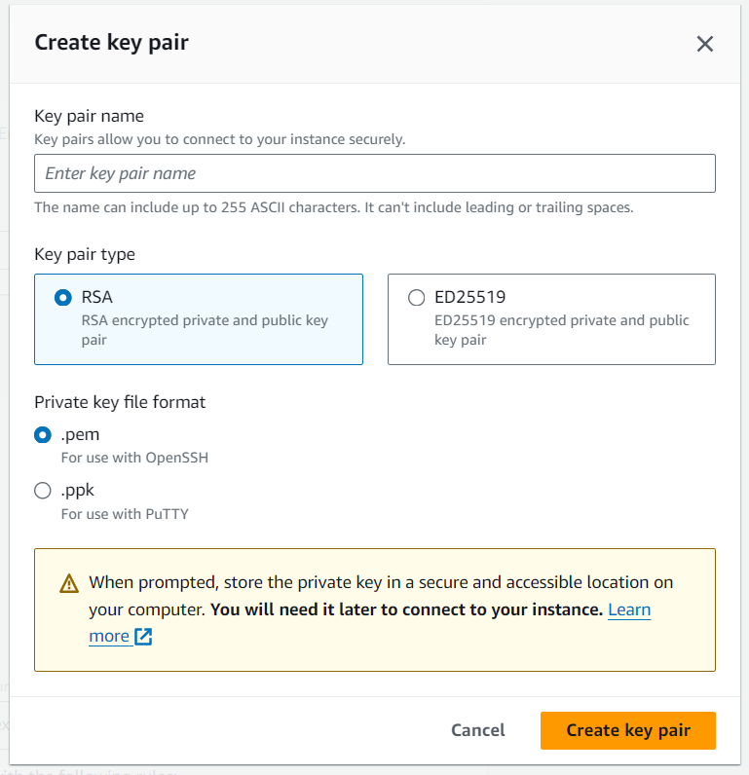

* Convert the key pair to ‘.pem’ file(Enter Key pair name and click on ‘Create key pair’ button’: Key pair pem file is download)
* Choose an key pair name in drop menu

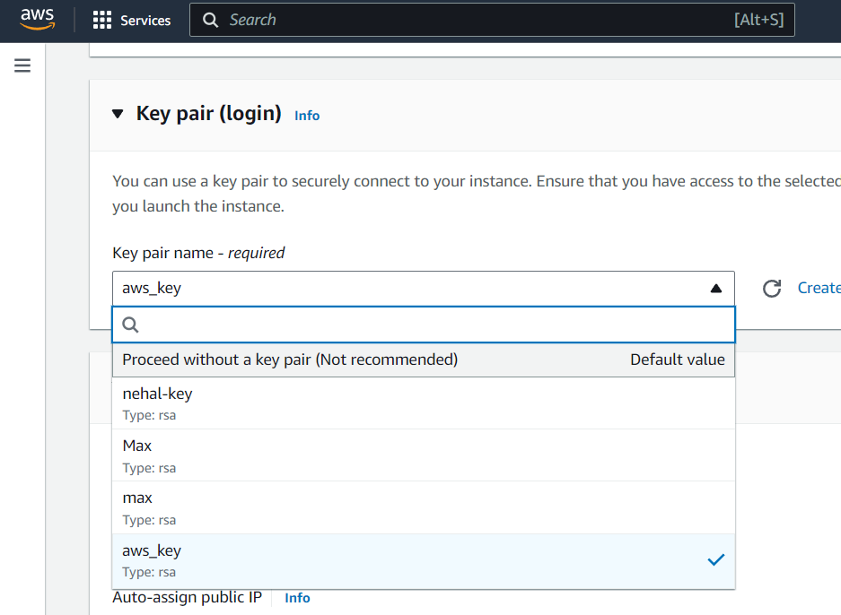

1. Network settings: default Network, Subnet.

* Security group: which Ips can reach the instance over network
* We choose the protocol, port and the source from which we want our instance to be accessible
* Select ‘Allow SSH traffic from’ and source as ‘Anywhere’.

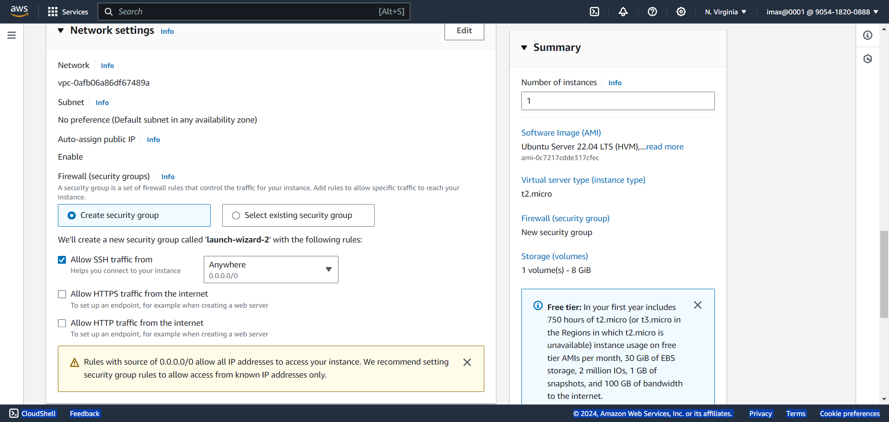

1. Configure storage:

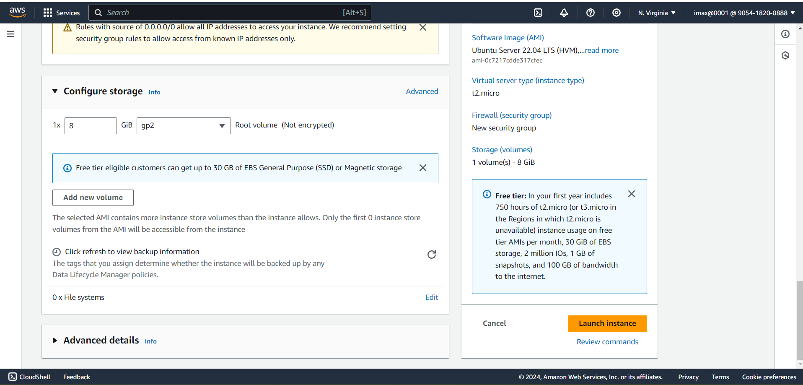

The following figure shows the relationship between these storage options and your instance.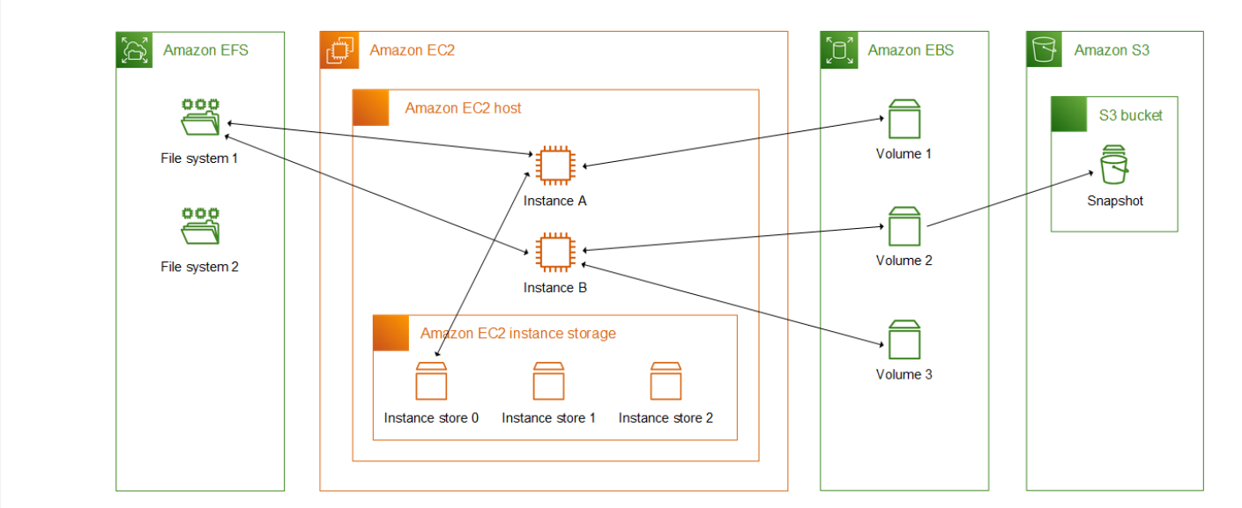

1. Click on Launch Instance button

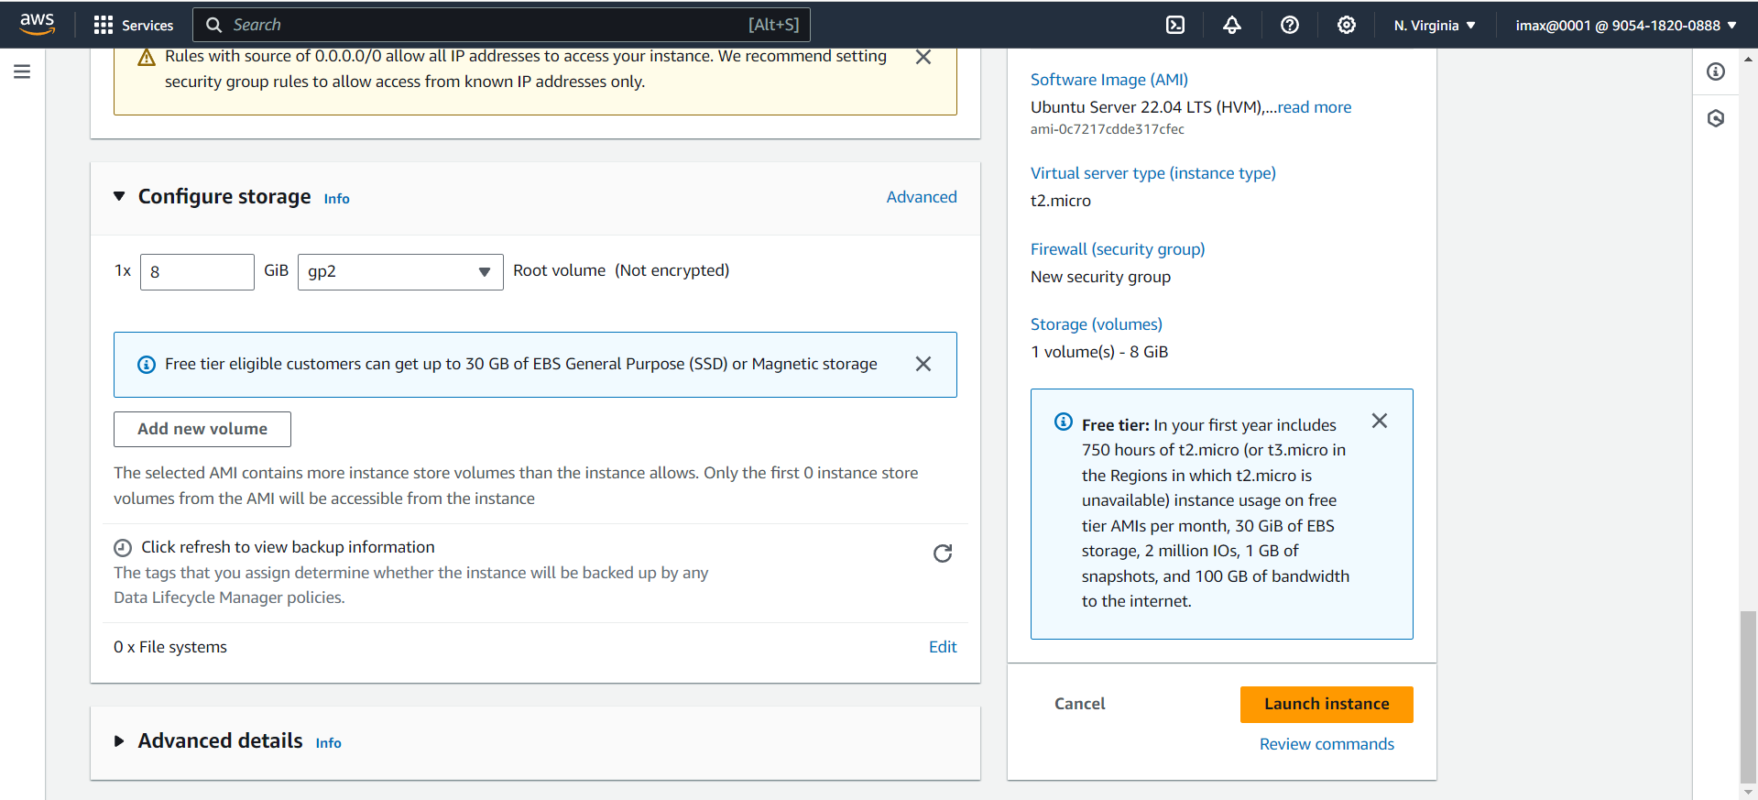

After launch the instance the page is display like this

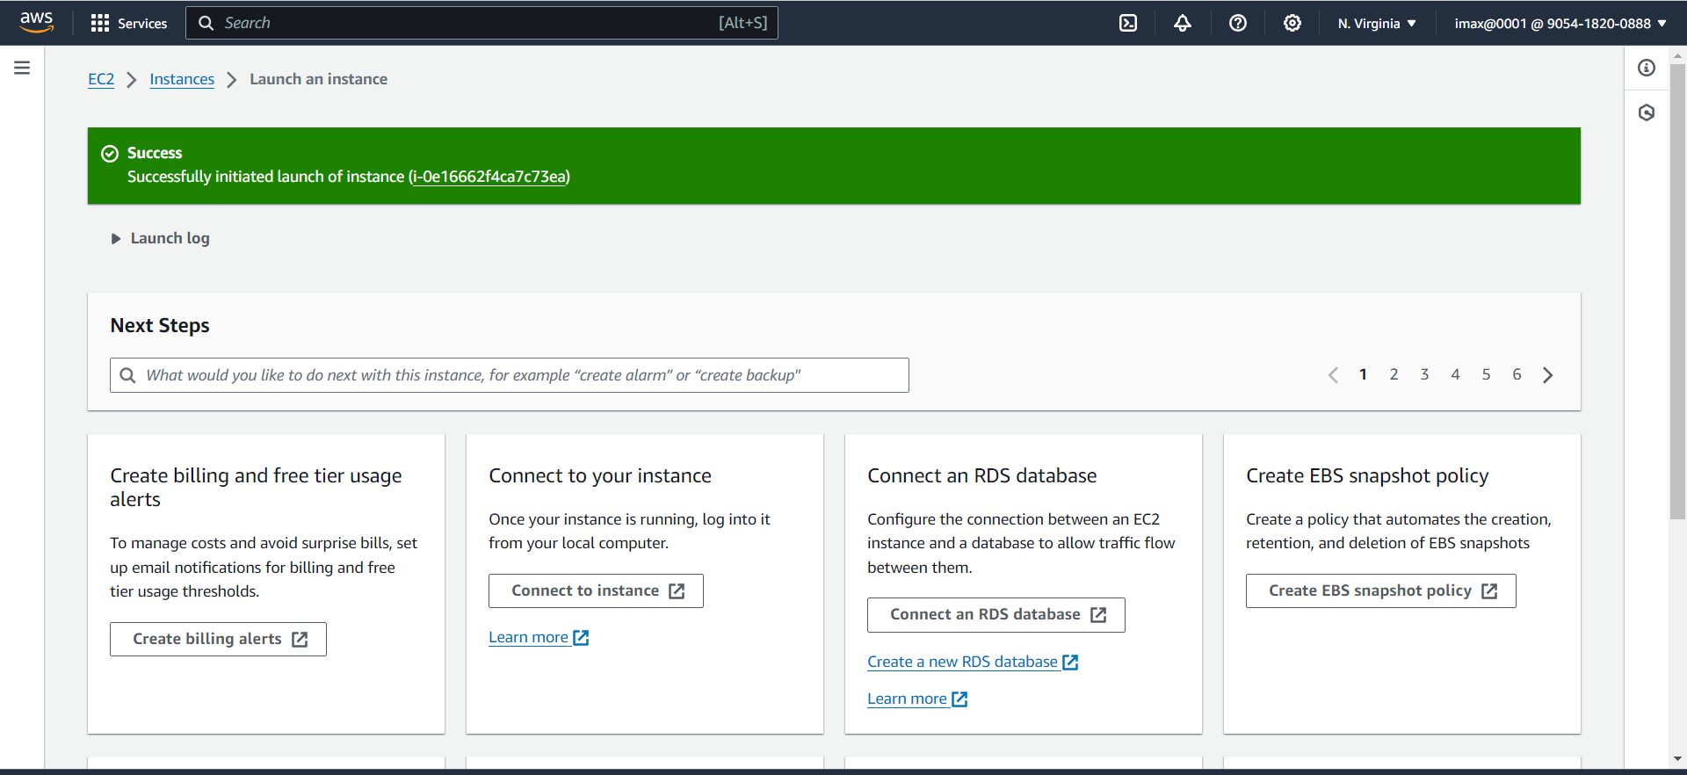

1. Then Go to instance tab

In Instance tab you can see the entry

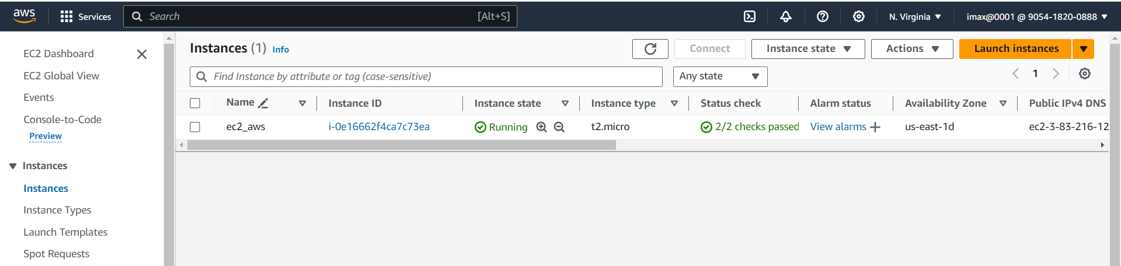

1. Open Git bash from where key pair is downloaded

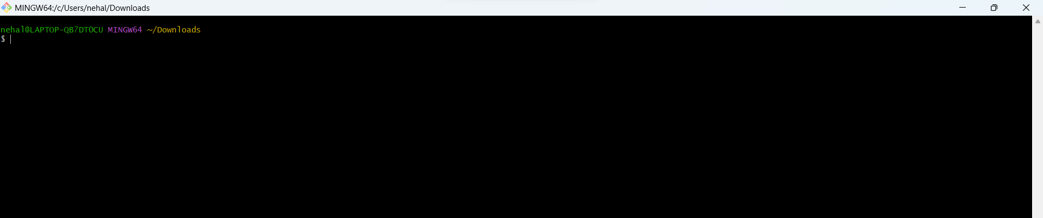

1. Creating machine as Remote using command (ssh -i "aws_key.pem" [ubuntu@ec2-3-83-216-127.compute-1.amazonaws.com](mailto:ubuntu@ec2-3-83-216-127.compute-1.amazonaws.com)) and enter

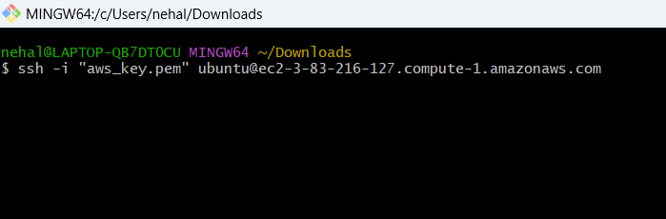

1. Type yes for continue connecting and enter

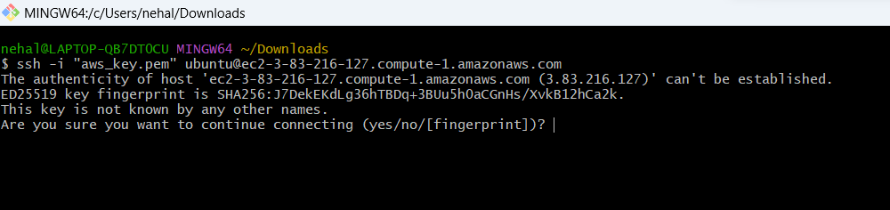

1. Successfully EC2 Instance Access Remotely

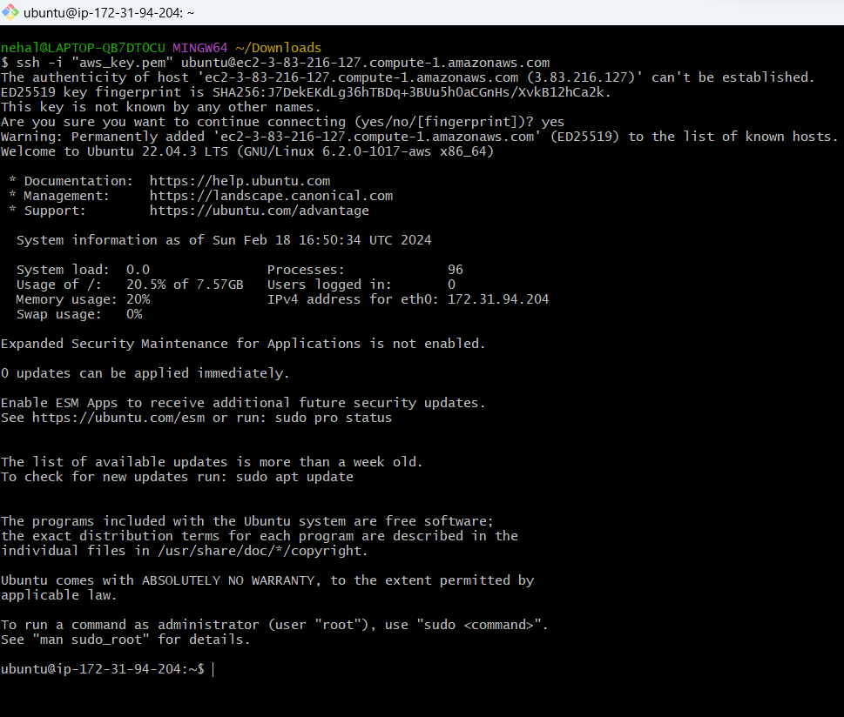

**Termination process**

1. Go to Instances page > Click on checkbox > In Instance state drop menu click on terminate option then we can terminate the Instance

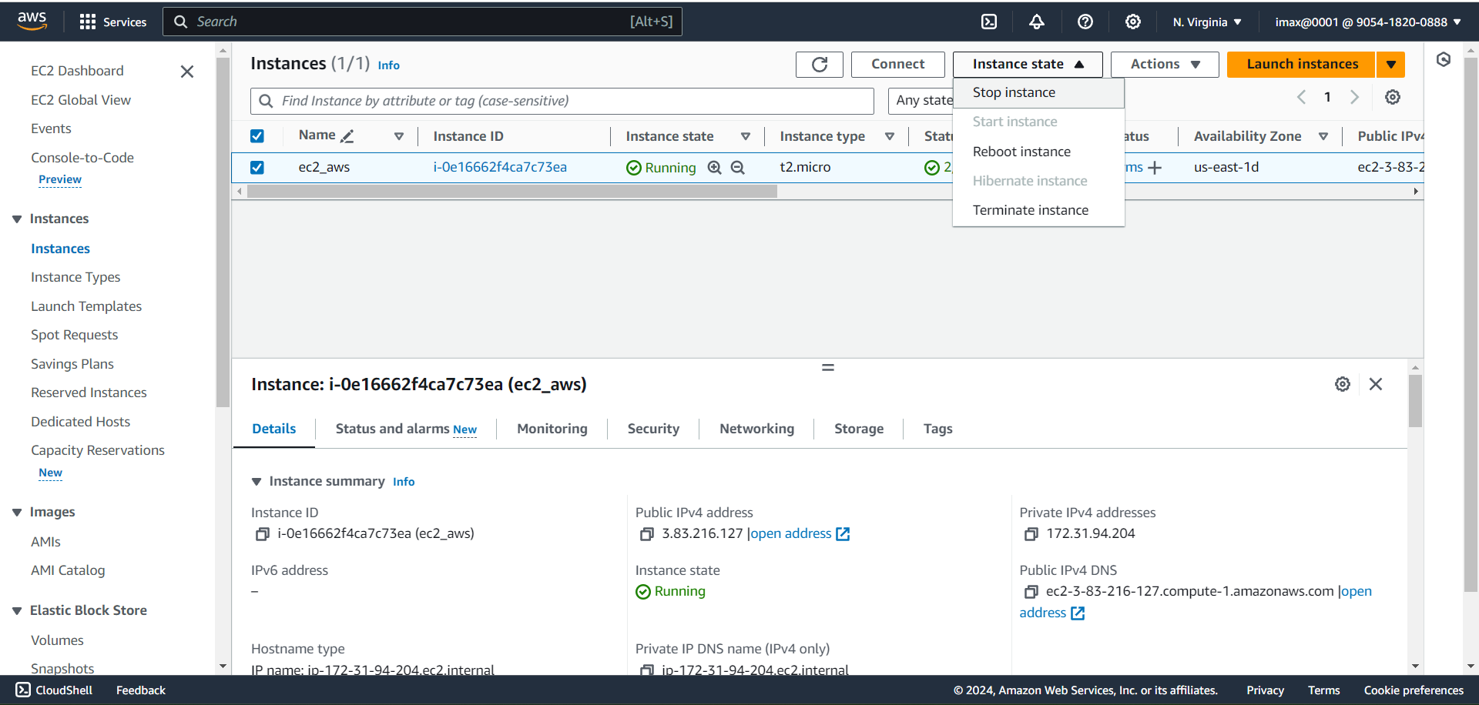

1. Click on Terminate

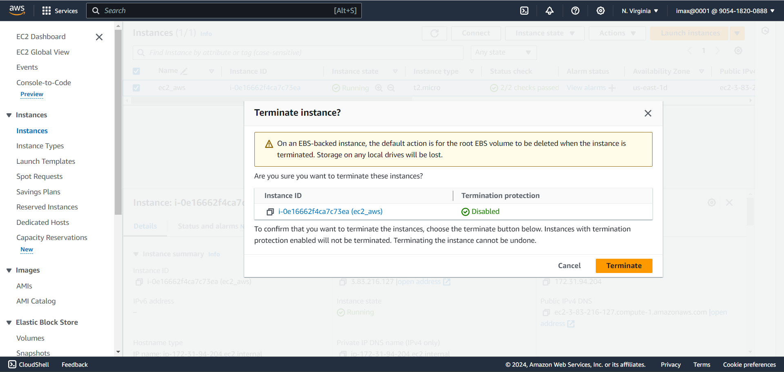

1. Successfully Terminated

